The 2015 Michigan Lean Consortium Conference:

“2015 – Transforming The Future NOW”

Dates: August 11, 2015, (optional pre-event spirits/wine tasting)

August 12-13, 2015 (official conference days)

August 14, 2015, (optional post conference workshops)

Location: The Hagerty Center at Northwestern Michigan College
715 E. Front St
Traverse City, MI 49686
Look for Signs: Great Lakes Campus; McManus Archway

Who Should Attend: Those who strive to transform Michigan’s businesses and governments by sharing lessons learned, being innovative and employing transcending concepts with the utilization of customer focus mentality, exemplary leadership and experimentation.

Evening of August 11th
5:30 – 7:00 PM Optional evening networking event at Grand Traverse Distillery
(additional $20.00 fee applies – pre-registration required)
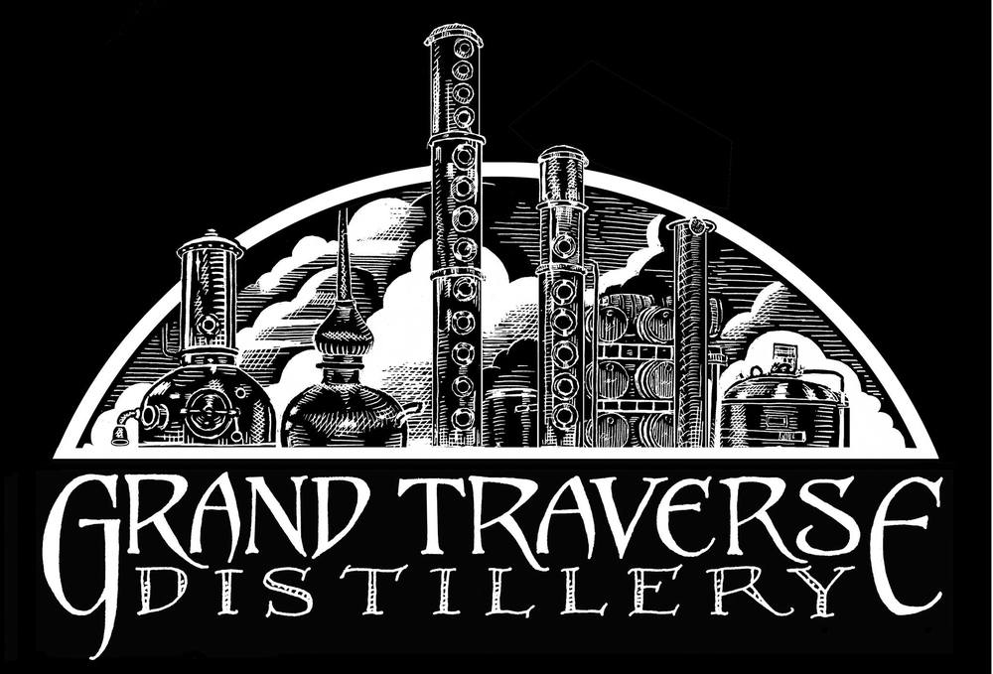
Located at 781 Industrial Cir #5, Traverse City, MI 49686 (231) 947-8635, you will be able to taste wine and spirits, tour the facility and taste cheese from The Cheese Lady for only $20! This is a great chance to network and meet new people before the conference begins on Wednesday.

Day 1: Wednesday, August 12

7:30 - 9:15 AM Check-in Opens & Continental Breakfast
9:15 - 9:30 AM Conference Welcome & Opening Comments
9:30 - 10:30 AM Keynote Speaker Darrell Rogers-“Sociology of Success”
10:30 - 12:30 PM Breakout Sessions
12:30 - 1:30 PM Lunch & Networking
1:30 - 3:30 PM Breakout Sessions
3:30 - 3:45 PM Break
3:45 - 4:30 PM Networking Session
4:30 - 4:45 PM Day 1 Reflection, Giveaways & Announcements
5:00 - 6:15 PM Reception-Hors Devours + Cash Bar

Day 2: Thursday, August 13
8:00 - 9:00 AM | Breakfast & Networking
9:00 - 10:00 AM | Keynote Speaker Richard Sheridan-“Chief Storyteller (CEO) Menlo Innovations
10:00 - Noon | Breakout Sessions
Noon - 1:45 PM | Lunch & Keynote Speaker Mike Zimmer-“Reinventing the Reinvention Platform”-Transforming State Government
1:45 - 3:45 PM | Breakout Sessions
3:45 - 4:00 PM | Day 2 Reflection, Awards & Giveaways – Conference End
Day 3: Friday, August 14-Optional Workshops
additional fee applies
$20.00 for full conference attendees
$99.00 if only attending workshop

7:30 - 8:15 AM Breakfast & Networking
8:15 – 12:15 PM Workshop-Option 1
Red Bead Redux Featuring the Funnel Equipment
Facilitators-Gerald Brown & Jim Manley
Workshop-Option 2
Extraordinary Leadership-Fundamentals of Success
Facilitator-Dennis Sergent

Hotel Information
Rates apply to the nights of August 11, 12 and 13.
Book by July 10th, 2015 to secure these rates
Refer to ‘Michigan Lean Consortium’ when booking.
Comfort Inn Traverse City

460 Munson Ave
Traverse City, MI 49686
Phone: (231) 778-8000

Double Queen Room
$175/night
Cambria Suites

255 Munson Ave (US-31)
Traverse City, MI 49686
Phone: (231) 778-9000

King Suite
$225/night
Double Queen Suites
$215/night

Bayshore Resort*

833 East Front Street
Traverse City, MI 49686
Phone: (231) 935-4400

15 standard no view rooms: $177/night
15 East side view rooms: $187/night

Holiday Inn West Bay*

615 East Front Street
Traverse City, MI 49686
Phone: (231) 947-3700

Holiday Inn
$179.95/night

Country Inn and Suites

420 Munson Avenue
Traverse City, MI 49686
Phone: (231) 941-0208

Standard Single - Queen/King $160.00/night
Business Class Suites
$190.00/night

*Within walking distance of the conference center

