The 2016 Michigan Lean Consortium Conference:

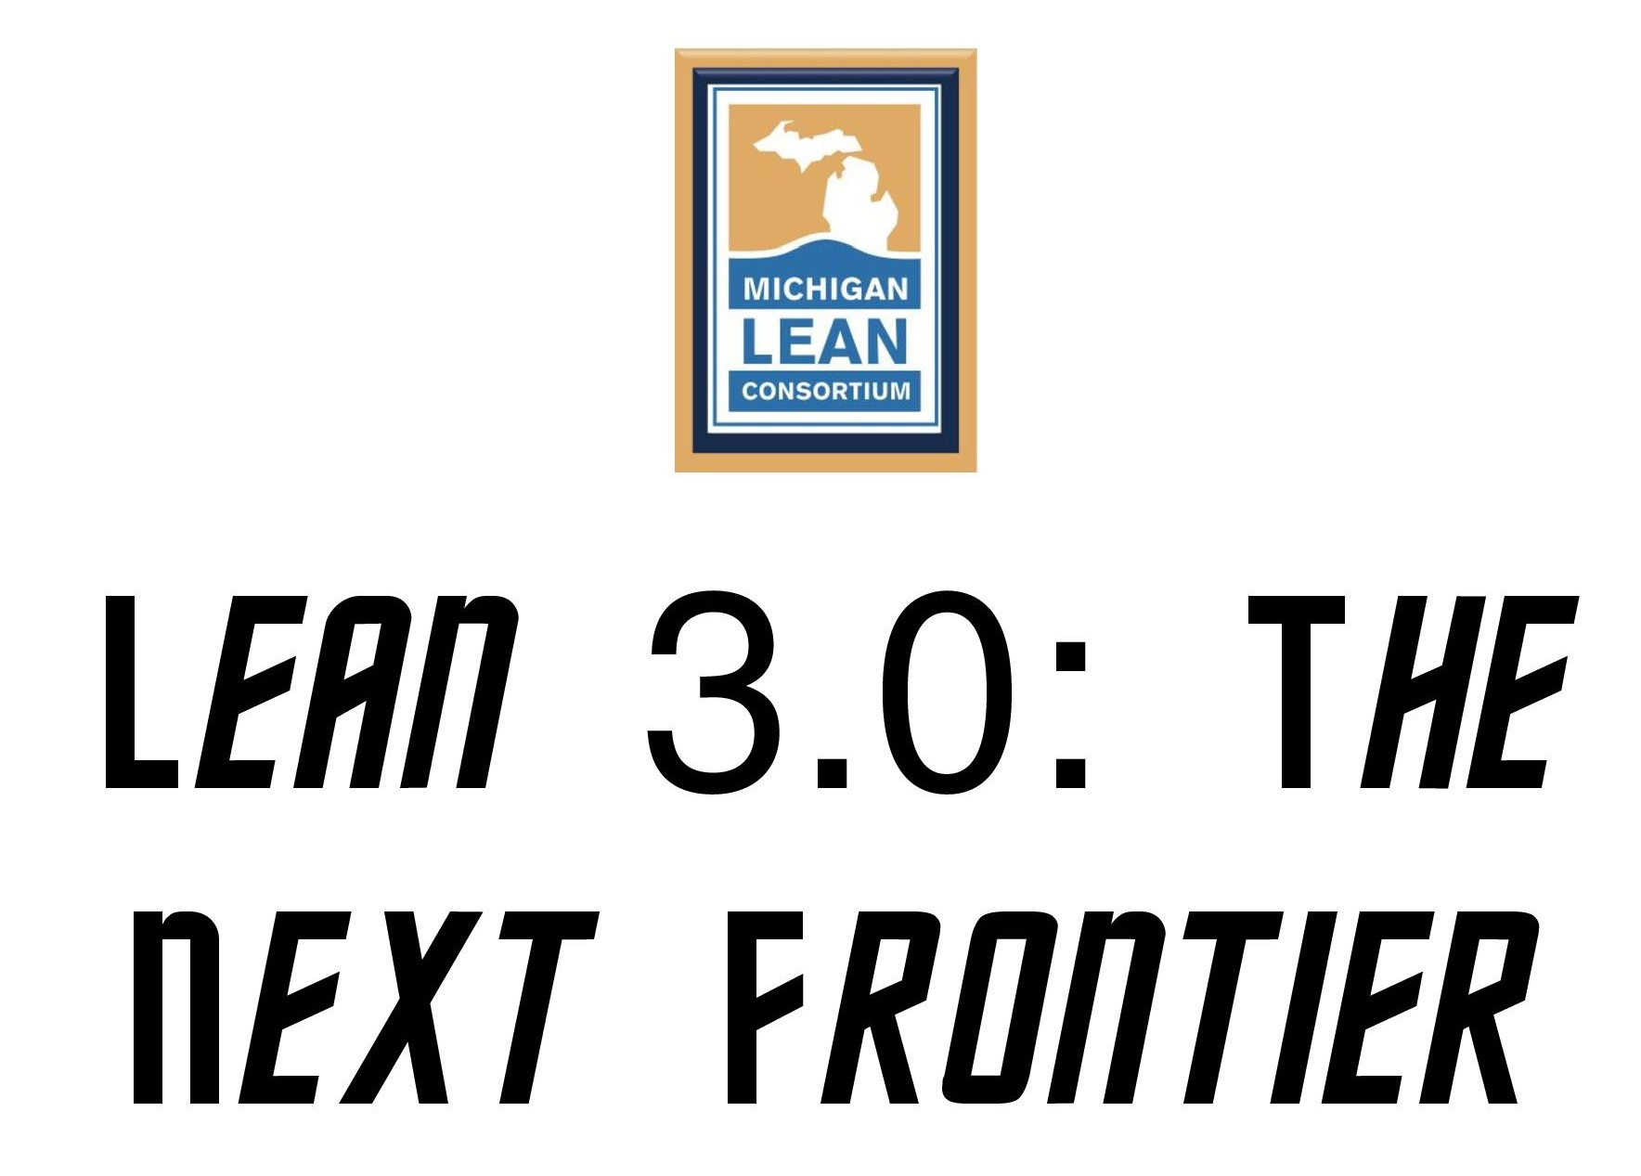

Dates: August 2, 2016 Evening Social Event (additional fee)

August 3-4, 2016 Official conference days

August 5, 2016 Optional post conference workshops (additional fee)

Location: The Hagerty Center at Northwestern Michigan College
715 E. Front St
Traverse City, MI 49686

Who Should Attend: Those who strive to transform Michigan’s businesses and governments by sharing lessons learned and developing their teams into innovative problem solvers. This year’s focus is on the future and how lean could be used to create trends.

Day 0: Tuesday August 2

5:00-7:00pm Social Event at Chateau Chantal
Tour of the Winery, Tastings, Beautiful Views
$30 per person; maximum 40 people

Day 1: Wednesday, August 3

8:30 – 10:00 AM Check-in Opens & Continental Breakfast
10:00 – 10:15 AM Conference Welcome & Opening Comments
10:15 – 11:15 AM Keynote Speaker
Betty Gratopp, Lead Production Manager
Zingerman’s Mail Order
11:30 - 12:30 PM Breakout Sessions
12:30 - 1:30 PM Lunch & Networking
1:30 - 3:30 PM Breakout Sessions
3:30 - 3:45 PM Break
3:45 - 4:45 PM Networking Session
4:45 - 5:00 PM Day 1 Reflection, Giveaways & Announcements
TBD Reception-Hors Devours + Cash Bar
6:00 - 8:30PM Sunset Cruise (Tall Ship, band, boxed dinner, bar)

Day 2: Thursday, August 4

8:00 - 9:00 AM | Continental Breakfast & Networking
9:00 - 10:00 AM  10:00- 10:15 AM | Keynote Speaker:  Teresa Hay McMahon, Executive Director, Iowa Lean Consortium  Break
10:15 -12:15 PM | Breakout Sessions
12:15 - 1:00 PM | Lunch
1:00 – 2:00 PM  2:00 – 2:15 PM  2:15 - 3:15 PM | Keynote Speaker #3 (tentative)  Break  Breakout Sessions
3:15 - 3:45 PM | Day 2 Reflection, Awards & Giveaways

Day 3: Friday, August 5-Optional Workshops

Additional fee applies
$50.00 for full conference attendees
$100.00 if only attending Friday

7:30 - 8:15 AM Continental Breakfast & Networking
8:15 – 12:15 PM “Improvement Kata Workshop” by Rick Fleming
“Developing Mapping Analysis Skills – How to Recognize Opportunities” by Les Sutherland

